Office of the Secretary of the State of Connecticut

Chaplin Form for Written Certification of Early Voting Location
and Early Voting Plan for 11/5/2024 State and Presidential Election

Section I: About Your Town

Name of town: Chaplin
Does your town have a population of 20,000 or more? No

Section II: Type of Event and Date

Select one: State and Presidential Election
Date of Event: November 5, 2024 State/Presidential Election and early voting on 10/21/24 thru 11/3/24, 10:00 a.m. to 6:00 p.m. except 10/29/24 and 10/31/24 hours 8:00 a.m. to 8:00 p.m..

Section III: Required Early Voting Location
Name of location: Ferrara Room located in the Chaplin Library/Senior Center Building
Address of location: 132 Chaplin Street, Chaplin, CT 06235
Contact information Registrar of Voters Christopher Komuves, 860-455-9839 and Eugene V. Boomer, Jr. 860-208-7026.

CVRS live connection? We are currently working to have a VPN setup in the Ferrara room for this purpose and it will be active for the election. If it is not active, we will move the early voting location to the Town Hall building which is where we conducted early voting in April and plan to for August.

Description of location interior: The Ferrara Room is located in the Library/Senior Center building WHICH IS a one story building with the Ferrara Room being to the left as you enter into the main entrance. The room is 37’ wide and 71’ long.
Upon entering the voters will go directly to the registrar’s table where they will show their id and the registrars will check them off on the early voting checklist. two separate voting booths will be just beyond the REGISTRAR’S TABLE. one of the booths will be an accessible booth. The IVS machine will be set up near the voting area in a way that provides privacy. the Ballot depository box will be located just beyond the voting booths, where it will be secured and visually monitored by all election workers. Voters will enter through the front door and continue to the registrar’s table, and then to the voting booths and then to the ballot depository box and then to the exit.

Description of location exterior: The Library/Senior Center building parking lot is located in front of the building with two accessible parking spaces and two curbside voting spaces. 75’ foot signs will be placed in the appropriate areas. Business as usual at the Library/Senior Center building with designated voting areas marked and signage directing voters to the Ferrara Room.

Section IV: Early Voting Plan
Early voting staff: Eugene v. Boomer, jr. – republican registrar. Doreen bolduc – republican assistant registrar. Christopher Komuves-democratic registrar, Gavin Horning-Kane — Democratic Deputy Registrar” and “Ann Lewis — Democratic Assistant Registrar

Location where ballots will be stored each day after early voting: BALLOTS WILL BE STORED IN A LOCKED CABINET INSIDE OF THE TOWN CLERK’S LOCKED VAULT AT THE END OF EACH DAY OF EARLY VOTING.
Description of tamper-proof, fire-proof receptacle in which early voting ballots will be stored: The ballots will be transferred by both registrars from the sealed ballot depository box (that the voter placed the ballot into), to a sealed Handi Pouch Carrying Bag from LHS with a serial numbered seal. The serial number of the seal will be written on the Affidavit of Delivery of Early Voting Ballots and will be signed by both registrars delivering the ballots to the Town Clerk and by the Clerk receiving the ballots. Copies of the affidavits will be made with the original being stored inside of the carrying pouch mimicking as closely as possible the procedure currently used for delivery of absentee ballots to the polling place. The Clerk will place the sealed Handi Pouch carrying bag into a locked cabinet inside of the vault. Access to the cabinet is restricted solely to the Clerk.

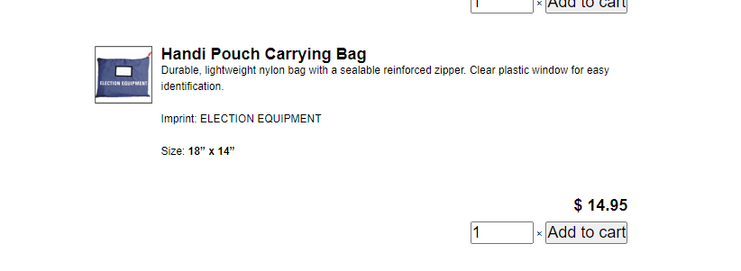

Name of the individual responsible for ballot storage and log*: Shari Smith, Chaplin Town Clerk.
*Election officials should store ballots in a fire-proof, limited-access area and maintain an access log. This log should include the name of anyone who accesses the area, as well as the date, time, and reason for access.

Any Additional Components of Early Voting Plan: Following emergency plan if necessary. Daily moderator provided with early voting manuals, moderator manual and all needed forms to perform responsibilities.

Sketch of Early Voting Room:

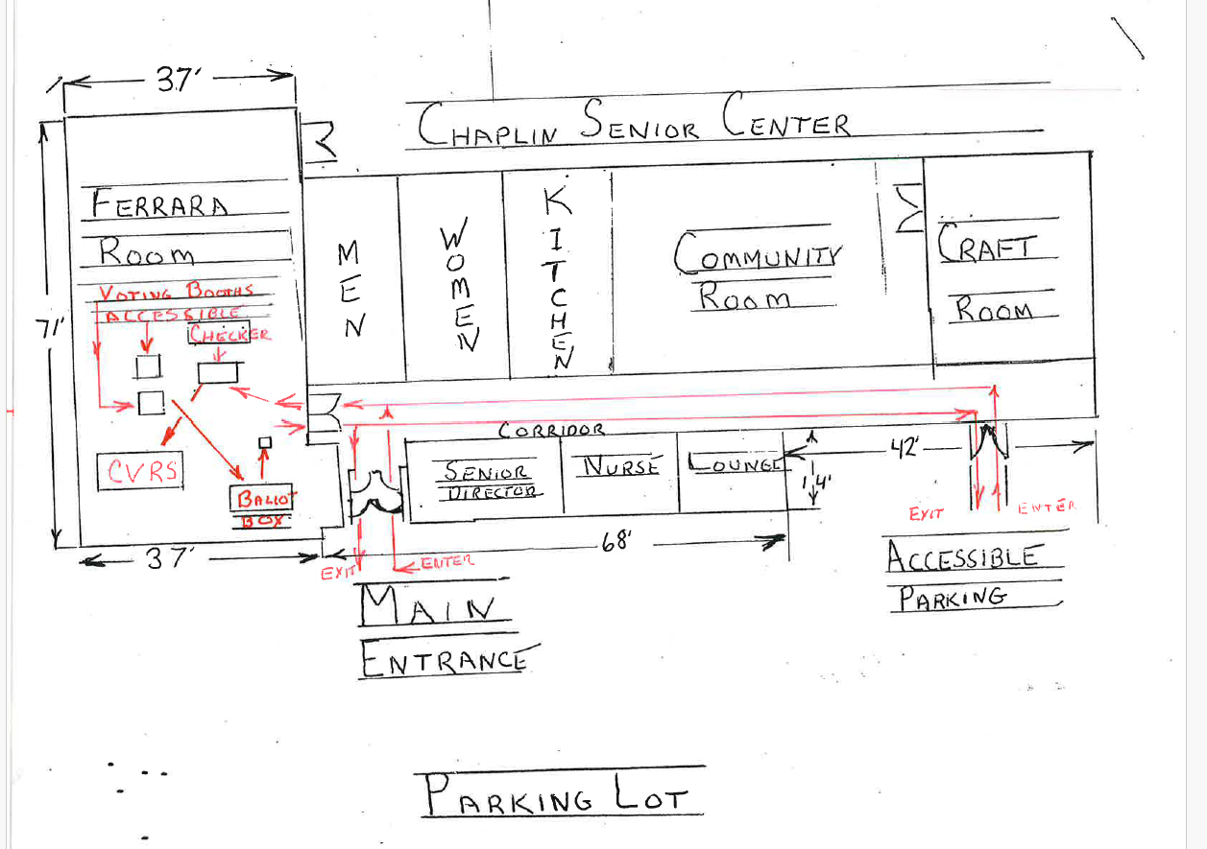
Submitted by: Eugene V. Boomer – republican registrar and Christopher Komuves – democratic registrar
Date: 7/23/24

For SOTS Use Only: Reviewed by/Date:
Comments:

